Reynolds Hall Facilities Manual
John Chambers
College of Business and Economics
West Virginia University | 83 Beechurst Ave
2022
Contents
B&E Building Emergency Plan 3
Term Definitions 3
Introduction 5
Responsibilities 5
Assistant Dean for Administration and Planning 5
Building Supervisor 6
Building Occupants should know the following: 6
Building Emergency Plan Requirements 7
BUILDING COMMAND TEAM 7
Building Supervisor/Secondary Building Supervisor 8
Building Description 9
Building Critical Operations 9
BUILDING DEPARTMENTS 10
BUILDING SAFETY COMMITTEE 11
Building Alarms (S) 11
Notification Procedures 11
Emergency Notification Procedures: 11
Non-Emergency Notification Procedures: 11
WVU Emergency Warning Notification System 12
Emergency Evacuation Maps 13
Emergency Procedures 18
Evacuation 18
Evacuation Policy: 18
GENERAL EVACUATION PROCEDURES 19
Building Specific Evacuation Procedures 20
Emergency Assembly Area Location 21
Evacuation Guidelines For People With Disabilities 21
Shelter-In-Place 22
Procedures: 22
Building Specific Shelter In Place Procedures And Locations 24
Acronyms and Resource List 26
External Automated Defibrillator (AED) 27
Building Hours 27
Building Access 28
Key distribution 28
Mailboxes 28
Space Allocation 29
Maintenance Requests 32
Building Signage 32

Building Information

B&E Building Emergency Plan

Term Definitions
All Hazards Warning Messages: WVU’s Alert Text Messaging system. This service is free to employees and students, and you may sign up from the WVU Homepage.
Building Supervisor: The Building Supervisor is a university employee who has a defined role in each campus building. Each WVU building should have at least a primary and a secondary Building Supervisor, appointed by the building administrator(s). In an emergency, the Building Supervisors should report to the Incident Command location to provide building information to emergency responders. The “All Clear” information will typically be communicated to the primary Building Supervisor when it is safe to return to the building, so that the occupants can be notified.
Building Command Team: The Building Command Team (BCT) is an organized group of decision makers from a specific building (normally 3-7). The BCT operates within the building, in a pre-designated room/area. This area is normally the same area that the first alert/emergency report comes to. The BCT has a deep understanding of all internal building operations, organizations, and BEP content. First Responder (command) should be pulled alongside the BCT for critical information sharing concerning the emergency incident (bomb threat, evacuation, search, etc.). Should the building require immediate evacuation (fire, fire alarm), the BCT should also have an external site, near the building, but safely away from hazards, and meet/link up with First Responders. A primary function of the BCT is to be the point contact between the building occupants and the First Responders, controlling the information flow concerning completed evacuation (to include any resident occupants requiring assistance for evacuation), coordination of movement for evacuated occupants to another location, and support the First Responders with internal building information (known building critical/hazardous operations). The decision-making process for bomb threat evacuation and/or an organized building sweep for suspicious packages/concealed devices, should be made collectively by the BCT and First Responders.
Building Emergency Plan: The plan is a document that consists of emergency procedures, activities for preparing for emergencies, and roles and responsibilities of building occupants.
Building Safety Committee: A group composed of members of each department in the building, generally chaired by the Building Supervisor or other employee, charged with coordinating building safety concerns. The Building Safety Committee program is administered by Environmental Health and Safety.
- Serves as a forum for building employees to report and discuss safety or environmental improvement needs.
- Identifies employee’s needs for safety training and requests training sessions accordingly.
- Coordinates safety self-audits on a regular basis; assists Building administrator(s) in prioritizing actions to address safety concerns.
- Disseminates information about requirements concerning workplace health, safety, and environmental protection.
Critical Operations: Any critical operations located in your facility that require preplanning for evacuation and/or Shelter-in-Place events, such as data storage, servers, or animal quarters, etc. This information is Public Safety Sensitive, but must be readily available to first responders to assist them in their emergency response efforts.
Hazardous Operations: Any potentially hazardous operations located in your facility that require preplanning for evacuation and/or Shelter-in-Place events, such as hazardous materials. This information is Public Safety Sensitive, but must be readily available to first responders to assist them in their emergency response efforts.
Outdoor Evacuation Assembly Area (OAA): A pre-designated safe location near a building where building occupants assemble and report to the Roll Taker(s) after evacuating their building.
First Responder(s): Person(s) who provide assistance in an emergency (or potential emergency) situation in a building. They are not building occupants and may be from West Virginia University Police Department, Morgantown Fire Department, Monongalia Emergency Medical Services (Mon EMS), WVU Environmental Health and Safety, WVU Facilities Services, etc. In critical situations, they may take charge of the building and have full authority over activities in and around the building.
Roll Taker: Building occupant(s) assigned by the Building Supervisor to take roll at the Outdoor Assembly Area(s) (OAA) after a building evacuation.

Introduction
The Building Emergency Plan is designed to assist in training students, faculty, staff and visitors in basic emergency information to include shelter-in-place and building evacuation procedures for natural and man-made events.
Please remember that the Building Emergency Plan itself contains Public Safety Sensitive Information about critical and hazardous operations in the building that must not be shared with the public or all occupants of the building for security purposes. All occupants of the building need to be familiar with appropriate emergency response information when there is an emergency in the building. Emergency warning notifications, evacuation, and shelter-in-place procedures need to be understood by all building occupants.
As a member of the University community, you should also be familiar with the University Emergency Operations Plan. This manual describes the procedures to follow in a variety of emergencies. A copy of the Plan can be viewed electronically at: https://police.wvu.edu/emergency-management/emergency-operations-plan.

Responsibilities

assistant Dean for administration and Planning

- Appoints a primary and a secondary Building Supervisor.
- Ensures that current information on the Building Supervisors (name, department, building room number, phone, and emergency phone numbers) is communicated to the Coordinator of the Building Supervisors Program. Lt. Joshua Cook,
Joshua.Cook@mail.wvu.edu
- Assigns the primary Building Supervisor, or other building employee, as Building Emergency Plan Developer, and works with that person to develop the individual Building Emergency Plan.
- Reviews and signs off on the Building Emergency Plan prior to submission to the WVU Police Emergency Planning Unit.

Building Supervisor

- Develops, with the Building Administrator(s), the Building Emergency Plan.
- Once the Building Emergency Plan is approved by the WVU Police Emergency Planning Unit, the building supervisor refers to it in training all building occupants in emergency response.
- Ensures that the Building Emergency Plan is available to the appropriate personnel and that it is used during emergency incidents.
- Reviews the Building Emergency Plan annually to ensure that information and procedures are current.
- Lists all Critical and Hazardous Operations in the Building Emergency Plan for First Responder reference and use.
- Adds the electronic link to the University’s Emergency Response Plan to the Building Emergency Plan.
- In the event of an emergency, ensure that emergency notification to emergency agencies takes place.
- Assists in building evacuation.
- Reports to Outdoor Assembly Area(s) (OAA) and ensure that Roll Call is taken of evacuated personnel.
- Collects and provides essential information to emergency personnel (e.g., location of incident, persons in building, special hazards, etc.).
- Develops additional building-specific information that makes the Building Emergency Plan more effective (e.g., specific procedures for any assigned disabled people, evacuation maps, etc.).
- Includes in the Building Emergency Plan any additional information as directed by the Building Administrator(s).
- Organizes at least one annual exercise or drill and elicits feedback and ideas for improvement.

Building Occupants should know the following:

- Evacuation routes and Outdoor Assembly Area(s).
- The University’s Emergency Warning Notification System.
- The locations of emergency materials that may be needed in an emergency, such as emergency telephones and fire pull alarms.
- The proper procedures for notifying emergency responders about an emergency in the building (dial 9-911 on campus, 911 from a public telephone or cell phone).
- Any additional building-specific procedures and requirements.
- To participate in annual exercises/drills.
- Consult their Building Supervisor with any questions.

Building Emergency Plan Requirements
The Building Emergency Plan is reviewed annually by the Building Emergency Plan Developer and the Building Administrator(s) to ensure that information and procedures are current. The University Police Emergency Planning Unit will also review the Building Emergency Plan, will maintain a copy for use by Emergency Operations Center personnel and will forward a copy to Monongalia Emergency Centralized Communication Agency (MECCA).
The Building Emergency Plan will be tested with an exercise at least annually to validate procedures and to ensure building occupants’ understanding. The exercise should be based on a simulated emergency event that highlights building shelter-in-place or evacuation procedures. Any lessons learned that require changes to the Building Emergency Plan should be incorporated into the Building Emergency Plan and a copy forwarded to the University Police Emergency Planning Unit. The University Police Emergency Planning Unit will assist in exercise development if needed.
Training is an integral part of the safety and preparedness program for your building. It is the responsibility of each department head and supervisor to ensure that all building occupants are trained or made aware of the Building Emergency Plan for the building(s) they occupy.

BUILDING COMMAND TEAM
Building Command Team (BCT) is the decision making/incident evaluation team for the building. This team should consist of senior administrator(s) and building supervisor(s). This team should have an interior designated meeting area, where emergency incident information is directed (team members should be notified and assemble here to assess the situation). The University Police Department and any other University support departments for this incident should meet the BCT at this location. The BCT should also have a designated exterior meeting area, in case of immediate evacuation. BCT should always be looking for any first responders (Police, Fire, EMS) and integrate them into the decision-making process.
Building Command Team Interior Meeting Location:
The BCT will meet at the Atrium on 2nd Floor Near Social Stairs
Building Command Team Exterior Meeting Location:
The BCT will meet at the north (2nd floor) entrance visitor parking area 50 feet away from the building.

BUILDING COMMAND TEAM
Name & Title | Department | Phone | Room
Josh Hall, Dean | Dean’s Office | 304-293-7870 | 6504
Mike Walsh, Associate Dean | Dean’s Office | 304-293-7960 | 6506
Rebel Smith, Associate Dean | Dean’s Office | 304-293-7957 | 6501
John Lympany, Assistant Dean | Dean’s Office | 304-293-7934 | 6510
Carole Kiger, Building Supervisor | Technology | 304-293-8557 | 5307
Greg Kramer, Assistant Building Supervisor | Technology | 304-293-7745 | 5304
Jamie Kiszka, Office Admin Sr. | Dean’s Office | 304-293-7800 | 6500

Building Supervisor/Secondary Building Supervisor
Building Name: | Reynolds Hall
Building Supervisor (BS): |  | Carole Kiger |  |  | clkiger@mail.wvu.edu
BS Department: |  | Technology
BS Campus Address: |  | PO BOX 6502, 83 Beechurst Ave
BS Campus  Telephone |  | 304-293-8557 |  | BS Emergency Telephone: |  | 304-276-6761
Assistant Building Supervisor: |  | Greg Kramer |  |  | gregory.kramer@mail.wvu.edu
Assistant BS  Department: |  | Technology
Assistant BS  Campus Address: |  |  | PO BOX 6502, 83 Beechurst Ave
Assistant BS  Campus Telephone: |  |  | 304-293-7745 | Assistant BS  Emergency Telephone (M-F: 8:15-4:45) |  | 304-365-4448
After-Hours Emergency Contact: |  |  | Carole Kiger | After-Hours Emergency Telephone: |  | 304-276-6761

Building Description
Six floors, Fitness Center, classrooms, offices, computer labs, three elevators, three stairwells, SEE ATTACHED FLOOR PLANS

Building Critical Operations

This section includes information about critical operations that require special care during an emergency, such as servers.
Operation | Room | Department | Responsible Person | Phone
NA
No critical operations in the building requiring special care.

BUILDING DEPARTMENTS
Department | Department Administrator | Phone | Building | Room
Academic Engagement Success Center | Rachel Nieman | 304-293-0546 | REH | 2217
Accounting | Richard Riley | 304-293-7849 | REH | 5142
Advising | Susan Catanzarite | 304-293-7957 | REH | 2211
Dean’s Office | Joshua Hall | 304-293-7870 | REH | 6504
Economics | Feng Yao | 304-293-7867 | REH | 4129
Business Office | Kristin Summers | 304-293-8172 | REH | 6503
Outreach and Engagement | John Deskins | 304-293-7876 | REH | 3122
Center for Chinese Business | Victor Chow | 304-293-7888 | REH | 4003
Strategic Communications | Heather Richardson | 304-293-9625 | REH | 6401
Career Development Center | Sarah Glenn | 304-293-8305 | REH | 3416
Development | Abigail Esguerra | 304-293-8888 | REH | 6508
Encova Center | Tara St. Clair | 304-293-7221 | REH | 3110
Finance | Ann Marie Hibbert | 304-293-2447 | REH | 4109
Graduate Programs | Zachary Thayer | 304-293-4364 | REH | 2106
Information Technology | Carole Kiger | 304-293-8557 | REH | 5307
Knee Center | Ed Timmons | TBD | REH | 6304
Management | Abhishek Srivastava | 304-293-7944 | REH | 6113
Marketing | Annie Cui | 304-293-6657 | REH | 6101
MIS | Graham Peace | 304-293-7940 | REH | 5122
Fitness Center | Lex Castleberry | 304-293-6652 | REH | 1003

BUILDING SAFETY COMMITTEE
Name & Title | Department | Phone | Building | Room
Josh Hall, Dean | Dean’s Office | 304-293-7870 | REH | 6504
Mike Walsh, Associate Dean | Dean’s Office | 304-293-7960 | REH | 6506
Rebel Smith, Associate Dean | Dean’s Office | 304-293-7957 | REH | 6501
John Lympany, Assistant Dean | Dean’s Office | 304-293-7934 | REH | 6510
Carole Kiger, Building Supervisor | Technology | 304-293-8557 | REH | 5307
Greg Kramer, Asst. Building Supervisor | Technology | 304-293-7745 | REH | 5304

Building Alarms (S)
Fire and Elevator alarms
When the fire alarm is activated, you will hear what Simplex calls CHIMES. They are located on the walls just above eye level. With the CHIMES you will see a white flashing light, and on the light, it is printed (FIRE). The alarm will not stop until someone locates the problem and takes care of it and then turns off the alarm. No one is permitted to turn off the alarm but fire control or the fire department.

Notification Procedures

Emergency Notification Procedures:
Any building occupant that needs emergency assistance should immediately dial 9-911 from any campus telephone or 911 from any public or cell telephone.

Non-Emergency Notification Procedures:
- College phone number: 304-293-7833
- Fire: Morgantown Fire Department (MFD) 304-284-7480
- Police: WVU Police Department (UPD) 304-293-3136
- Closest medical facility: Ruby Memorial Hospital - 304-598-4000 and Mon General Hospital - 304-598-1200
- Environmental Health and Safety: 304-293-3792 or 304-293-3795
- Facilities Management Help Line: 304-293-4357
- Facilities Management Zone Services: Maintenance Zone 3 - 304-293-4357 (Zone telephone number may be obtained at 304-293-(HELP))

WVU Emergency Warning Notification System
WVU is a large and complex institution, and people move about our campus freely. Despite advances in communication, there is no way to reach everyone instantly with a single message; however, the multi-layered approaches we have in place will help spread the word quickly, based on the circumstances. The following communication methods make up the University’s Emergency Communication Plan:
- All-Hazards Emergency Warning Text Message (Shelter-In-Place).
- Fire alarms (Evacuate the building).
- An e-mail alert will be sent to Building Supervisors. They, in turn, will activate a phone tree, forward e-mail to others in the building or go to offices or rooms in person. They also may post signs on doors or in hallways. These procedures will be covered in more detail during training.
- University Residence personnel will be notified. They activate their procedures to alert people in individual halls via their resident assistants, phones, and signage.
- An e-mail may be sent to all people with WVU and MIX addresses.
- The West Virginia home page (www.wvu.edu) is the focal point of the most complete information in all campus-related emergencies.
- University News and Information personnel will work with the news media— radio, TV, newspapers, and Internet — to help spread the word.
- Additional “phone tree” processes may be activated.

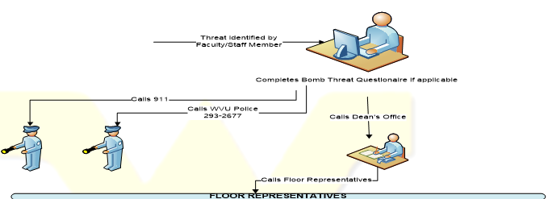
Floor Representatives Contacted
- First Floor: Fitness Center (3-7944)
- Second Floor: Graduate Programs (3-4364 or 3-0263), Undergraduate Programs (3-6514 or 3-5209), and AeSC (3-0546 or 3-7884)
- Third Floor: Career Center (3-8305 or 3-6513), Center Director (3-7923)
- Fourth Floor: Faculty Offices (Graham Peace 3-7940) and (Jack Dorminey 3-7845)
- Fifth Floor: BEIT (3-8557 or 3-7745), Faculty Office (Anne Hibbert 3-2447)
- Sixth Floor: Dean’s Office (3-7934), Strategic Communications (3-9265 or 3-7961)
Floor Reps Notify Everyone on the Floor and Guide them to the
Lots 7 and 11 on North and South side of Reynolds
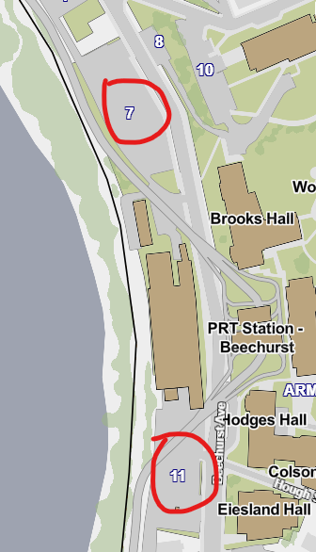
REMEMBER, WHEN YOU Receive:
- ALL HAZARDS text immediately seek shelter (Shelter-In-Place) in a safe location.
- FIRE ALARMS immediately evacuate the building and move to a safe location
In both cases, following the above action, you should solicit additional clarifying information by all possible means…WVU Homepage, TV, radio, email, etc.

Emergency Evacuation Maps
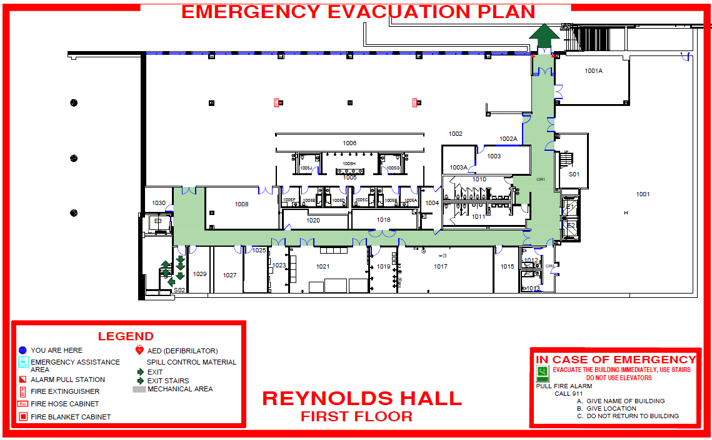

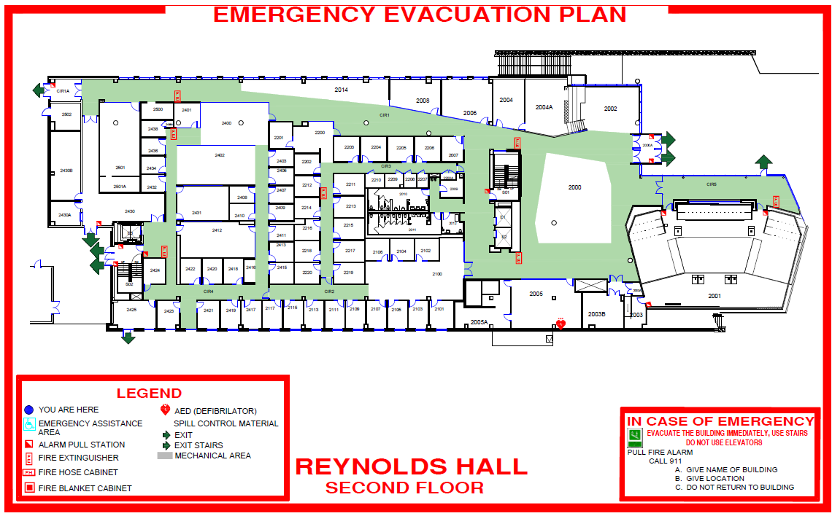

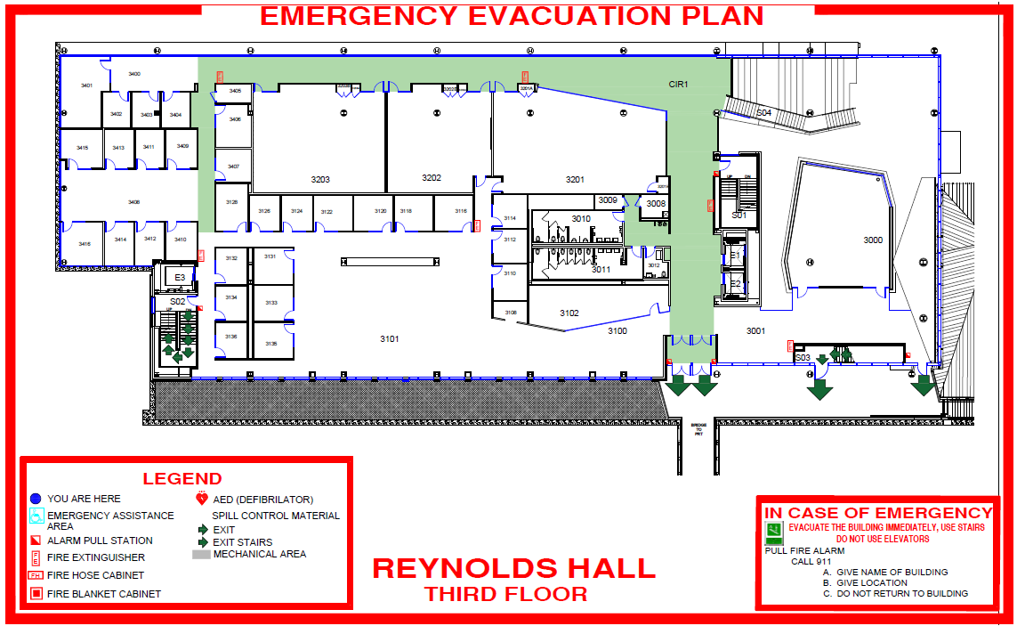

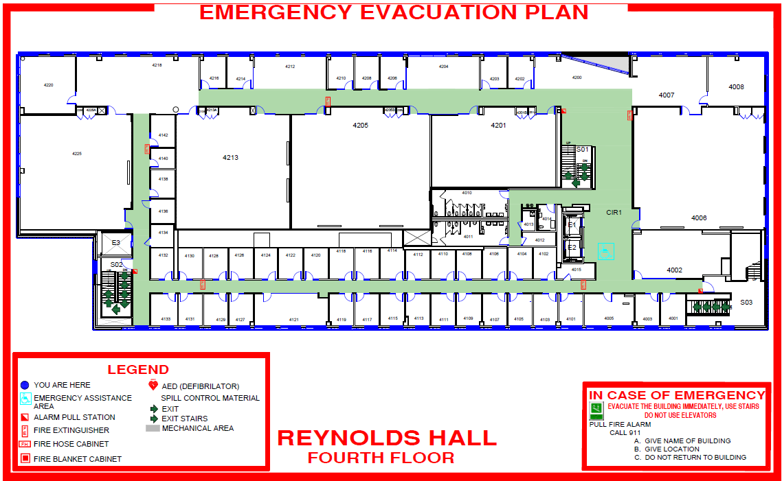

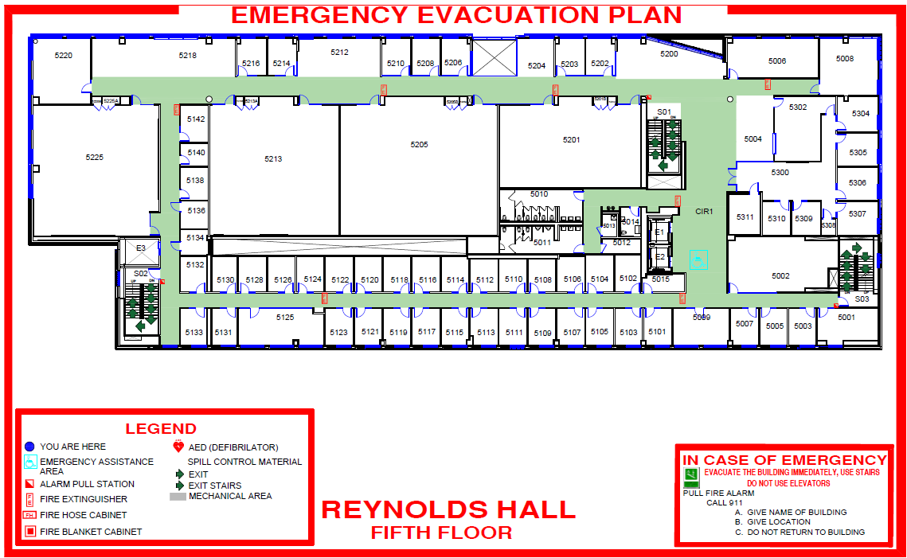

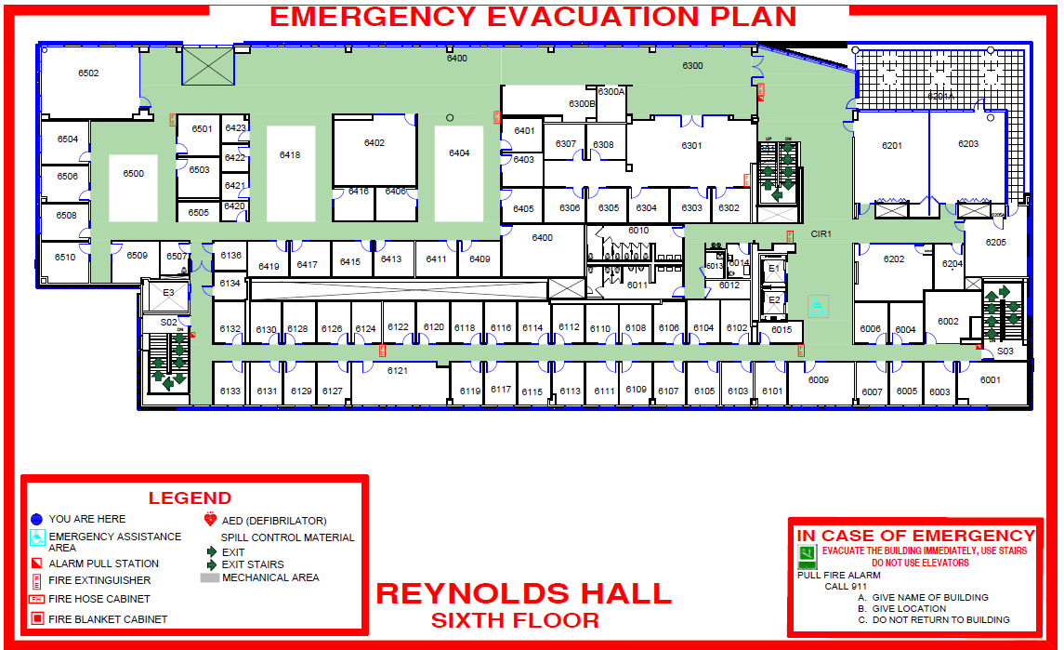

Emergency Procedures
WVU’s Emergency Response Plan will be referenced for all emergencies. A copy of the link must be attached to the Building Evacuation Plan (BEP).
The BEP focuses on two basic and immediate warning notifications:
- Fire Alarms mean to immediately evacuate the building and proceed to your Outdoor Assembly Area.
- All Hazards Emergency Warning Text means to immediately seek shelter (Shelter-In- Place) in a safe location within closest facility/building. “Shelter-In-Place” means seeking immediate shelter inside a building or University residence. This course of action may need to be taken during a tornado, earthquake, release of hazardous materials in the outside air, or a criminal/civil disturbance. When you receive the message, immediately go inside a building to a safe location and use all communication means available to find out more details about the emergency. Remain in place until police, fire, or other emergency response personnel provide additional guidance or tell you it is safe to leave.
Additional warning notifications will follow using the WVU Emergency Warning Notification System.

Evacuation

Evacuation Policy:
WVU policy requires immediate evacuation when any fire alarm sounds within a building. All employees, students and any other individuals within the building must promptly depart the building using designated exit routes.
  - Departments are responsible to ensure that all people in their building are aware of exit routes and location of their building Outdoor Assembly Area(s) (OAA).
  - Personnel may briefly delay evacuating if they need time to shut down electrical and other equipment, especially any that involves flame, explosive vapors, or hazardous materials.
  - All building occupants will follow instructions relevant to public safety issued by the Building Supervisor, or fire and police personnel.
  - After exiting the building, occupants are to go directly to their designated Outdoor Assembly Area(s) and follow guidance provided by the Building Supervisor, Building Administrator(s) and emergency responders.
  - No one may re-enter the building until authorized to do so by fire or police department officials.

GENERAL EVACUATION PROCEDURES
If You Hear The Fire Alarm Or Are Instructed To Leave The Building:
- Immediately obey evacuation alarms and orders. Tell others to evacuate.
- No one may remain inside a building when an evacuation is in progress.
- Classes in session must evacuate.
- If involved with hazardous research or doing a dangerous procedure, immediately shut down operations that could create additional hazards if left unattended. Evacuate as soon as possible.
- When you evacuate, take keys, coat, purse and any other critical personal items with you to the Outdoor Assembly Area(s).
- Close doors as rooms are vacated.
- Assist those who need help, but do not put yourself at risk attempting to rescue trapped or injured victims.
- Note location of trapped and injured victims and notify emergency responders.
- Walk calmly but quickly to the nearest emergency exit.
- Use stairways only. Do not use elevators.
- Keep to the right side of corridors and stairwells as you exit.
- Proceed directly to your designated Outdoor Assembly Area(s). Stay away from the immediate area near the building you evacuated.
- Remain in Outdoor Assembly Area(s) until Roll Call is taken and instructions are given.
- Do not reenter the building until authorized fire or police department personnel give the “All Clear” instruction.

Building Specific Evacuation Procedures
The College of Business and Economics has designated floor representatives in addition to Directors to assist in the evacuation of the building. The floor representatives are:
Floor | Name | Contact Information
First Floor | Fitness Center | 3-6651
Second Floor | Graduate Programs | 3-4364 or 3-0263
 | Undergraduate Programs | 3-6514 or 3-5209
 | AeSC | 3-0546 or 3-7884
Third Floor | Career Center | 3-8305 or 3-6513
 | Centers Director | 3-7923
Fourth Floor | Faculty Office | Graham Peace 3-7940
 | Faculty Office | Jack Dorminey 3-7845
Fifth Floor | BEIT | 3-8557 or 3-7745
 | Faculty Office | Anne Hibbert 3-2447
Sixth Floor | Dean’s Office | 3-7934
 | Strategic Communications | 3-9265 or 3-7961

If for any reason you evacuate to an OAA other than the one defined for your unit (for example a faculty member teaching class on another floor or an employee meeting on another floor) contact a director or floor representative at that OAA.
Refer to the building evacuation maps.

Emergency Assembly Area Location
Outdoor Assembly Areas (OAA—Roll Call) - Once out of the building, congregate with others in a designated Outdoor Assembly Area a safe distance away from the building. Remain at the designated area until told to reenter the building by the Dean or Dean’s representative. Designated areas are as follows:
EAA 1 | WHERE | Designated EAA | ROLE TAKING RESPONSIBILITY
 | Floor 1 to 3 | Lot 7 | Floor representatives
 | Floor 4 to 6 | lot 11 | floor representatives
 | The emergency assembly area where you go in the case of an emergency is determined by where you are at the time the alarm sounds

Evacuation Guidelines For People With Disabilities
First Floor | Exit on east side of building near the fitness center or the south side near the receiving area
Second floor | Exit through doors near social stairs or through vestibule at south end of building
Third floor | Exit through vestibule and cross bridge
Floors 4, 5, 6 | Go to nearest stairwell or elevator and wait for assistance

Check on people with special needs during an evacuation. A “buddy system,” where people with disabilities arrange for volunteers (co-workers) to alert and assist them in an emergency is recommended.
Only attempt an emergency evacuation if you have had emergency assistance training or the person is in immediate danger and cannot wait for emergency services personnel.
Always ask someone with a disability how you can help before attempting any emergency evacuation assistance. Ask how he or she can best be assisted or moved, and whether there are any special considerations or items that need to come with the person.
Faculty and staff who are mobility impaired should let the Building Supervisor know the location of their usual work area and special needs. Document the information in the table below.

Shelter-In-Place

You may be required to Shelter in Place for events such as:
- Tornado warning
- High winds
- Active shooter
- Building intruder
- Civil disturbance
- As directed by police personnel for any other situation that requires you to find protection within a building.

When To Shelter-In-Place:
You must immediately seek shelter in the nearest facility or building (preferably in a room with no windows) when:
- You receive an All-Hazards Emergency Warning message.
- You are directed to do so by police or fire department personnel.

Procedures:
The WVU ALERT Warning System (text messaging system) will be used to notify the campus community of a “shelter in place” situation.
If you are “sheltering” due to a tornado warning, immediately go to a safe location in your building.
- Proceed to the basement of any building that has a basement or sub-walk. Position yourself in the safest portion of the area away from glass. Be prepared to kneel facing a wall and cover your head.
- In high-rise (four stories or more) buildings, vacate the top floor and move to a lower floor or to the basement. Position yourself in an interior corridor away from glass. Be prepared to kneel facing the wall and cover your head.
If time permits, occupants of wood-frame or brick buildings with wood floors should leave the building and go directly to a more substantial concrete building, preferably with a basement.
- Any occupant who encounters a student or visitor should direct them to take appropriate actions.
- Any occupant that encounters a physically disabled individual should assist them if possible.
- After getting to a safe location and without jeopardizing your safety, try and obtain additional clarifying information by all possible means (e.g., WVU Homepage, TV, radio, email, etc.)
- If you are “sheltering” due to a hazardous materials (HAZMAT) accidental release of toxic chemicals the air quality may be threatened and sheltering in place keeps you inside an area offering more protection. For a HAZMAT situation you should, if possible, take the following actions:
  - Close all windows and doors.
  - Turn heating/cooling systems (HVAC) off.
  - Move to the shelter in place location.
  - Do not go outside or attempt to drive unless you are specifically instructed to evacuate.
  - Do not use elevators as they may pump air into or out of the building.
  - Any occupant that encounters a student or visitor should direct them to take appropriate actions.
  - Any occupant that encounters a physically disabled individual should assist them if possible.
  - After getting to a safe location and without jeopardizing your safety, try and obtain additional clarifying information by all possible means (e.g., WVU Homepage, TV, radio, email, etc.)
  - If you are “sheltering” due to an active shooter, building intruder or a civil disturbance on campus, immediately go to a safe location in your building (normally the police department or the All Hazards Sirens will be the notification method).
  - If possible, take refuge in a room that can be locked.
  - If possible, close and lock the building’s or room’s door(s). If unable to lock the door secure it by any means possible but avoid using your body.
  - The room should also provide limited visibility to anyone outside of it.
  - Hide under a desk, in a closet, or in the corner.
- After getting to a safe location and without jeopardizing your safety, try and obtain additional clarifying information by all possible means (e.g., WVU Homepage, TV, radio, email, etc.)
- Report any suspicious activity if you can do so without jeopardizing your safety…Call 911 if possible.

Building Specific Shelter In Place Procedures And Locations
Shelter-in-Place procedures must consider any specific building and occupant needs. Add maps, routes, other steps, actions, or precautions specific to your building or work area. Specify your shelter-in-place locations.
Community Response Checklist- Active Shooter, Building Intruder, or a civil disturbance.
If you are “sheltering” due to an active shooter, building intruder or civil disturbance on campus, immediately go to a safe location in your building (normally the WVU Police Department will put out an ‘ALERT warning notification, by text/e-mail”; this will be the primary notification method).
If the threat is inside your building (active shooter)’ Get Out, if safely possible; if you can’t safely get out, Hide Out, stay where you are and lock your suite of office door. If you are not in a location where the door can be locked, if possible, make your way to an adjacent room for higher level security (if the option to flee the building ‘safely’ does not exist). SPREAD OUT, if sheltering with others (lock/block doorway, turn off lights, silence phones, plan between yourselves). When you can safely do so, Call Out, to alert police and or others; Help Out others, when you can. Be prepared to possibly face the threat until police arrive, if so, Take Out the threat, if necessary. Keep in mind, there are no perfect answers…and too many possibilities to pre-plan for everything. A presence of mind by basic pre-thinking, knowing your building/area and taking the “Shot’s Fired” course offered on the WVU Police website https://safety.wvu.edu/safety-on-campus/active-shooter is the first/most important step to take (even if the answers are not clear at the time)… this will help you to avoid panic!

Secure Immediate Area:
• Lock and barricade doors
• Turn off lights
• Close blinds
• Block windows
• Turn off radios and computer monitors
• Keep occupants calm, quiet, and out of sight
• Keep yourself out of sight and take adequate cover/protection i.e., concrete walls, thick desks, filing cabinets (cover may protect you from bullets)
• Silence cell phones
• Place signs in exterior windows to identify the location of injured persons
Un-Securing an Area:
• Consider risks before un-securing rooms.
• Remember, the shooter or perpetrator will not stop until they are engaged by an outside force.
• Attempts to rescue people should only be accomplished without further endangering the persons inside a secured area.
• Consider the safety of masses vs. the safety of a few.
• If doubt exists for the safety of the individuals inside the room, the area should remain secured.
Contacting Authorities:
• Use Emergency 9-911 from all campus phones
• Use 911 from all non-campus phones, including cell phones
What to Report:
• Your specific location - building name and office/room number
• Number of people at your specific location
• Injuries - number injured, types of injuries
• Assailant(s) - location, number of suspects, race/gender, clothing description, physical features, type of weapon(s) (long gun or handgun), backpack, shooters/perpetrators identity if known, separate explosions from gunfire, etc.

Police Response:
• Objective is to immediately engage assailant(s)
• Evacuate victims
• Facilitate follow up medical care, interviews, counseling
• Investigation

Acronyms and Resource List

BCT: Building Command Team
BEP: Building Emergency Plan
BS: Building Supervisor
OAA: Outdoor Assembly Area
MFD: Morgantown Fire Department
UPD: West Virginia University Police Department
EH&S: WVU Environment Health and Safety Department

University Police Emergency Planning Unit: 304-293-2677
The office serves as the focal point for emergency preparedness questions and issues. Its web site can be found at http://police.wvu.edu

Environmental Health and Safety: 304-293-3792 or 304-293-3795
Information on various safety topics, including hazard evaluations and employee training can be found online at https://www.ehs.wvu.edu

Facilities Management: 304-293-4357
Installation and repair of facility safety equipment; maintenance services can be found online at https://facilitiesplanning.wvu.edu

West Virginia University Police: 304-293-3136
Information on personal safety in the workplace can be found online at http://police.wvu.edu

External Automated Defibrillator (AED)

An External Automated Defibrillator (AED) in the workplace can greatly increase a person’s chance of survival in the event of sudden cardiac arrest. Statistics show that survival rates increase from about 5% without an AED to as high as 74% with an AED.

Reynolds Hall has two AEDs. One is located on the 3rd floor near the elevators on the north end of the building and the other is in the Fitness Center on the first floor. They are in an alarmed box. In the event of a cardiac emergency, the responder will call 911 and provide the appropriate care. If the AED is used, the program coordinator will notify Environmental Health and Safety (EHS) as soon as possible following the incident. EHS will contact the medical director for a written review of the operation of the AED. EHS will send this review to the WV department of EMS.

The Building Supervisor is the Business and Economics AED Program Coordinator.

Building Hours
Academic Year: (Mid- August to Mid-May)
Monday – Thursday 6am – 10pm
Friday 6am – 8pm (fitness center only after 5pm)
Saturday – 10am – 8pm (fitness center only)
Sunday – 10am – 8pm (fitness center only)

Summer Hours (Based on class schedules)
Monday – Thursday 6am – 9pm
Friday – 6am – 6pm
Saturday & Sunday – Closed (fitness center hours TBD)

Requesting to open the building on off-hours:
If you schedule a classroom through 25 live for the weekends, the building supervisor receives a weekly report showing that the building needs to be open on the weekends.
For all other request, e-mail the building supervisor and include the follow:
- Name of the event
- Date of the event
- Time of the event
- Contact Person

The building will be open one hour prior to the event and close one hour after the event ends. If using conference rooms after hours or on weekends, electronic access will be needed and can be obtained by contacting Information Technology at BEITHelp@mail.wvu.edu.

Building Access
All full-time faculty, staff, administrators, and PhD students are granted building and elevator access.
Adjuncts are granted building and elevator access upon request from their departmental chairperson.
Students are not granted building access. If a student needs access, a written request with significant justification needs to be submitted from the department chairperson to the building supervisor.

Key distribution
The College has two types of locks in the building. The outside doors, elevators, conference rooms, labs and office suites are on-line electronic locks. Access can be granted by the Building Supervisor as needed for business.
All other locks which are primarily on office doors have keys to access them. Each employee is issued one key to their office. Additional keys are not maintained by the College.
Faculty may request a key for their student worker. The request must be made in writing. E-mail your request to BEITHelp@mail.wvu.edu. The faculty member is responsible for retrieving the key from the student at the end of their service.
A fee of $5.00 is charged to replace all lost keys.

Mailboxes
Mailboxes are in the receiving area for incoming and outgoing mail. Incoming mail will be distributed by the Dean’s office. Outgoing mail can be placed in the appropriate mailbox in receiving.

Space Allocation
All WVU owned space is allocated by the President to individual colleges, schools, departments, and programs based on need. As such, no space is "owned" but rather is "allocated" for specific purposes. B&E will follow the WVU Space Guidelines.
As these purposes continually change as programs ebb and flow, a new assignment of space may be necessary to meet the current programmatic needs of the college. The College reserves the right to re-allocate space based on departmental growth, changes in programs, etc.…
Academic Units | Traditional Hard Wall Space |  |  | Open Concept Space
 | Sq. Ft. | Code | Space Type | Sq. Ft. | Code | Space Type
President | n/a | PO-1 | Private Office | n/a | PO-1 | Private Office
Vice President/Provost, Chancellor | 275 | PO-2 | Private Office | 275 | PO-2 | Private Office
Associate/Assistant Vice President,  Vice Provost | 200 | PO-3 | Private Office | 200 | PO-3 | Private Office
Dean | 175 | PO-5 | Private Office | 175 | PO-5 | Private Office
Director | 150 | PO-4 | Private Office | 150 | PO-4 | Private Office
Associate/Assistant Dean | 150 | PO-4 | Private Office | 150 | PO-4 | Private Office
Associate/Assistant Director,  Manager, Department Head, Division, Chair | 120 | PO-6 | Private Office | 120 | PO-6 | Private Office
Faculty | 110 | PO-6 | Private Office | 120 | PO-7 | Private Office
Adjunct Faculty, Post Doc, Emeritus  Faculty (2 per office) | 60 | SO-1 | Shared Office | 60 | SO-1 | Shared Office
Administrative | 64 | OO-1 | Open Office | 64 | OO-1 | Open Office
GA, Student Workers  (Multiple per office) | 40 | SO-2 | Shared Office | 20 | SOO-  1 | Shared Open  Office
Private phone/conference space | 100 | SH-1 | Shared Space | 100 | LS-1 | Life-space Floor to  Ceiling Walls, Door

Office assignment guidelines (based on WVU Standard Guidelines)
First priority will be given to faculty, staff and then PhD students/students as space permits.

Faculty office – 110 sq. ft.

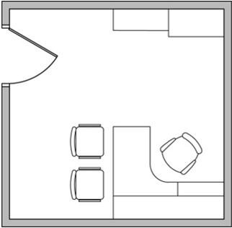
Administrative – 64 sq. ft.

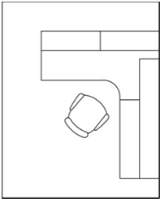
Adjunct faculty, post doc, emeritus (2 per office)
60 Sq. Ft.

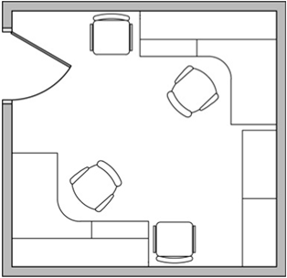

30-40 Sq. Ft./Person or (3) in a 100/120 Sq. Ft. Office
GA desk
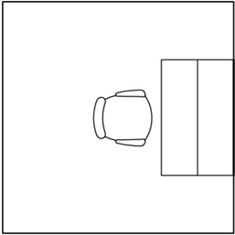

Note: All information provided is based on WVU standard space and furniture guidelines.
Three students share space 100 – 120 sq. ft.
120 Sq. Ft. Office

100 Sq. Ft. Office

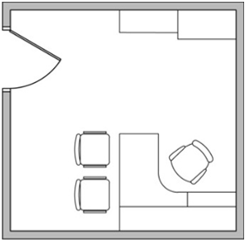

Maintenance Requests
Submit all routine maintenance requests to the Building Supervisor. Requests can be e-mailed or phoned in. Requests will then be entered into the WVU Unifier system for facilities. The work will be completed by the appropriate work crew.
Emergency work orders will be called into the WVU help line (293-HELP or 293-4357) and someone will be dispatched immediately.

Building Signage
Office Signs – each employee is provided with a name plate for outside their office. Name plate will be first initial and last name. Faculty will have an additional 8.5” x 11” sign holder to post office hours and/or other needed information.
Signs are not to be posted in the building. Digital signage options are available by contacting the Strategic Communications department. Any other signage requires approval by the Dean’s office.
No signs are to be placed in the stairwells. This is against fire regulations.
Only official WVU notifications are to be taped to the outside glass doors.

7/20/2022

